QuickStart Application: Teams

Submission Date: March 15, 2019, 5:00 PM PST

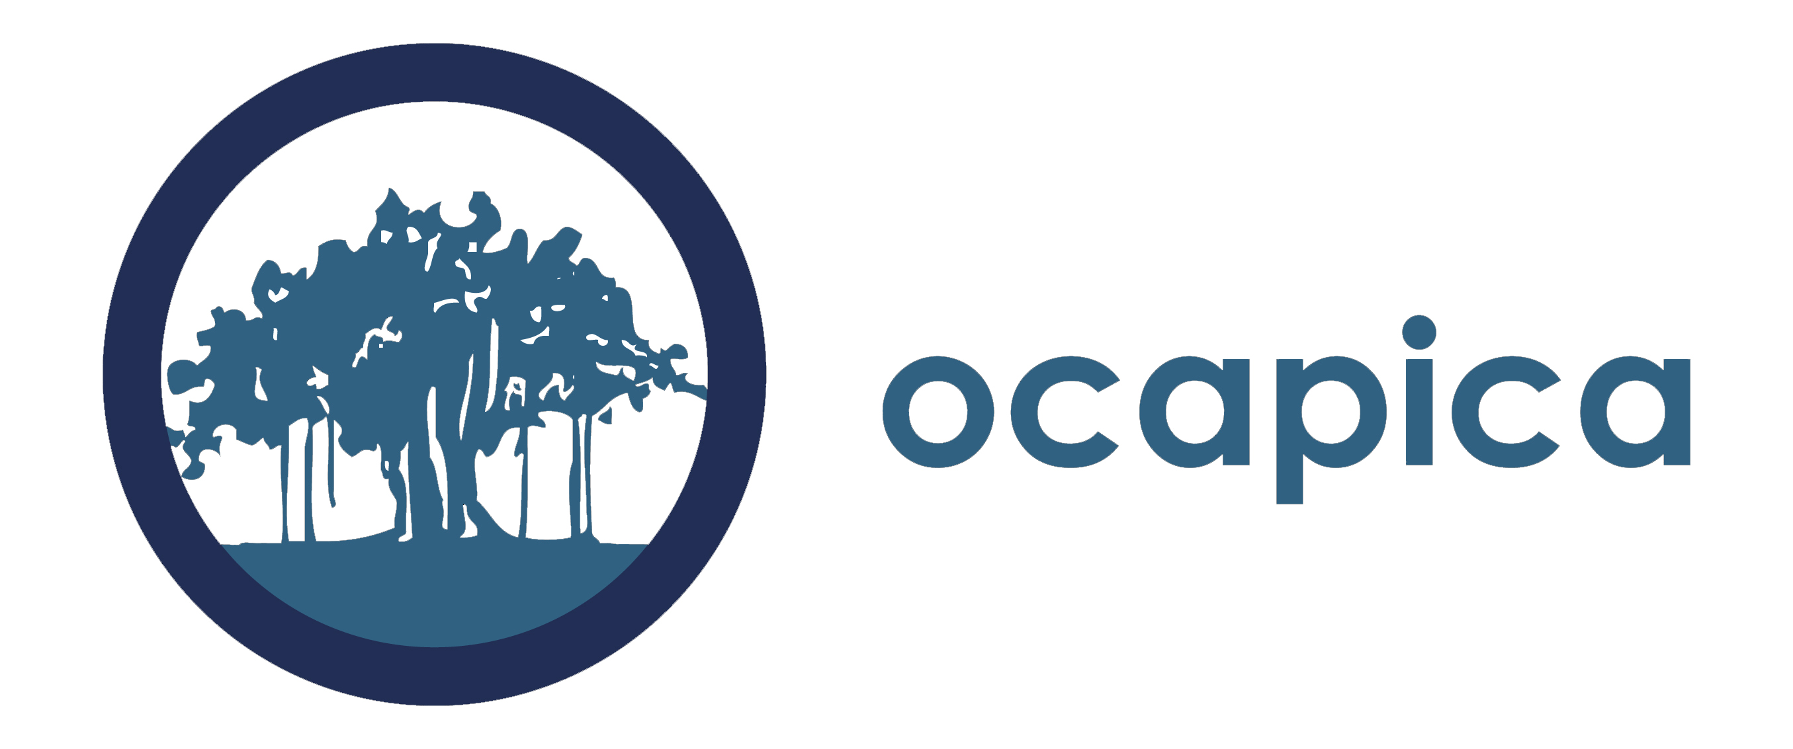

QuickStart Application Guidelines for
New and Existing Scientist-Community Partnerships

Together the Scientist co-PI and Community co-PI should fill out the partnership overview on page 3 and provide complete answers to questions A-C on page 4. Combine all pages of the application into a single word document and email it to QuickStart@cabreastcancer.org by 5pm PDT on March 15, 2019.

Your complete application (excluding letters of reference and resumes/CVs) should not exceed six pages. A downloadable word version of this is also available on the QuickStart webpage: http://cbcrp.org/funding-opportunities/crc/quick-start-training.html

Please submit your application as a word document.

Application Checklist:
Please include the following in your completed application:

- Partnership overview: See form on page 3.
- Application questions: See questions on page 4.
- Letter of Reference. Each of the partners includes a letter of reference from an organization or individual familiar with his/her work. For academic partners, a letter from a previous collaborator is appropriate. For community partners, a letter from your community organization in support of this application is required.
- Resume or Curriculum Vitae (CV) (Not to exceed 4 pages). Each partner must submit either a resume (community partner) or a CV (academic partner) that is not to exceed four pages.

Mentorship plan request: For accepted academically-trained scientist applicants with less than five years post-doctoral experience as a researcher, or without NIH R01 funding, an acceptable plan to gain mentorship from a seasoned investigator is required prior to the start of QuickStart.

Please note: The packet for completing and submitting a mentorship plan will be provided to the scientific Co-PI after the acceptance of the team. A mentorship plan will not be required of the community Co-PI.

Partnership Overview for Scientist and Community Partners

Community Co-PI Name
Organization Name
Address
Email
Work Phone
Cell Phone
Fax Number
Executive Director Name
Work Phone
Email
Scientific Co-PI Name
Institution
Address
Email
Work Phone
Cell Phone
Fax

How many years has your team worked together? Or, If this is a new partnership, how did you meet?
What previous research studies have you conducted together (if applicable)?
Who is your community of interest?
What disparities issues are of most concern to you?
What environmental issues in breast cancer or tobacco related disease are of most concern to you?
If you are not planning to investigate disparities and/or environmental issues in breast cancer or tobacco related disease, what are your primary issues of concern?
Will the scientific Co-PI be submitting a mentorship plan? (See requirements on page 3). If not, please indicate how many post-doctoral years has the research scientist been working in the research field. Please also list the year, funder, and name of study of most recent NIH RO1 funding.

A. Overview of your partnership (2–3 pages).
Together the community co-PI and scientific co-PI prepares a two to three page overview in response to the questions below. Please include the questions with the answers filled in underneath when you submit.

  - Who is part of your partnership? What experience, interests, and skills do they bring?

  - Describe your experience and position in your organization/institution.

  - How did your partnership meet and why have you chosen to work together? If you are an existing partnership, how did you begin to work together and what is your history of working together?

  - Describe each partner’s experience working in partnerships and/or collaborations (other than above) and (if applicable) in community-partnered participatory research.

  - Describe your common research interests. For example, describe the types of research questions that are interesting to you.

  - If there are other individuals who are likely to be significantly involved in the research process with your partnership, please describe them and their proposed contribution. Please note: if you would like one of them to be considered for participation in th program, please indicate who they are and why it would be important for them to participate. QuickStart cannot guarantee that more than two partners will be able to participate in the program; however, we will consider a third partner if there is available space.

B. Description of the Organization/Institution Involved (1–2 pages each). Each partner prepares a one to two page overview of their organization/institution they will represent in the QuickStart program,, that includes the following details. Please include the questions with the answers filled in underneath when you submit.

- Describe the mission of the organization/institution, the issue the organization/institution focuses on, the geographic reach of the organization/institution, the demographics of the population the organization/institution serves, and the types of services the organization/institution provides.
- Describe your organization/institution’s experience collaborating with others.

- Describe the research interests of the organization/institution (if different than above).

- Given the research needs and interests of the organization/institution, why is the individual applying a good candidate for this program?

- How will the organization/institution select a replacement for the individual if he/she resigns his/her position with the organization/institution?

C. Is there anything else you would like the QuickStart team to know as we consider your application?

