QuickStart Application: Individual Scientist Co-PI Seeking a Community Co-PI

Submission Date: January 23, 2019, 5:00 PM PST.

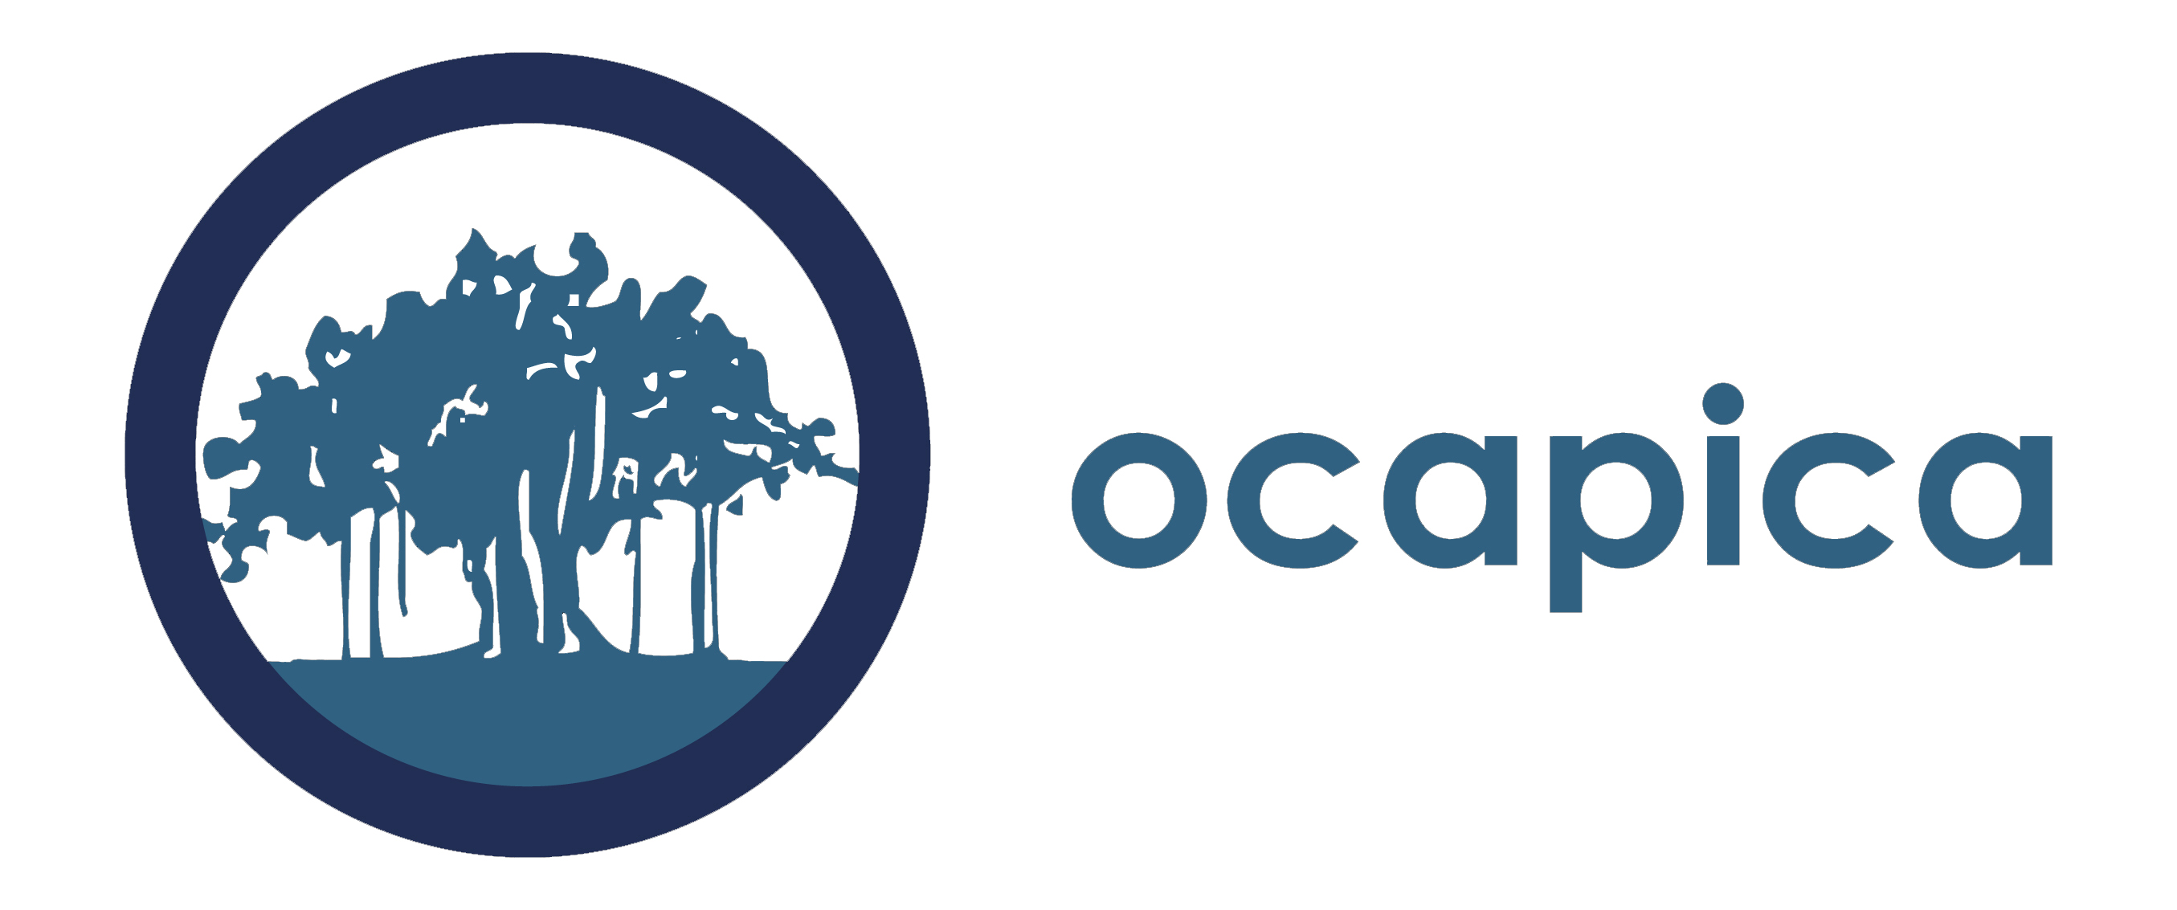

QuickStart Application Guidelines for
Scientist Co-PIs seeking a Community Co-PI

The Scientist co-PI should fill out the overview form on the next page (page 3) and provide a narrative overview in response to the questions on the following page (page 4). Combine all pages of the application into a single word document and email it to QuickStart@cabreastcancer.org by January 23, 2019, 5pm PST.

If the scientist co-PI is selected for the QuickStart program, the team will assist them in identifying pathways to identifying and reaching out to potential community co-PIs to work with. Additionally, we will make introductions to community members if we know of potential candidates. The QuickStart team cannot promise that the scientist co-PI will be able to find a partner in advance of starting the program, however all reasonable efforts will be made to do this.

You complete application (excluding letters of reference and resumes) should not exceed six pages. A downloadable word version of this is also available on the QuickStart webpage: http://cbcrp.org/funding-opportunities/crc/quick-start-training.html

Please submit your application as a word document.

Application Checklist:
Please include the following in your completed application:

- Overview of Scientist Co-PI Seeking a Community Co-PI: See form on page 3.
- Application questions: See questions on page 4.
- Letter of Reference. Includes a letter of reference from the organization you represent demonstrating support for your participation in QuickStart.
- Resume or CV (Not to exceed 4 pages).

Overview of Scientist Co-PI Seeking a Community Co-PI

Scientific Co-PI Name
Institution
Address
Email
Work Phone
Cell Phone
Fax Number
Would you like the QuickStart team to help you find a community partner for the program? If not, please explain how you plan to find a partner for QuickStart.

Please give some key words of the type of scientific research you are qualified to do (ex. Toxicology, Epigenetics, etc)

Have you worked on either breast cancer or tobacco related research in the past? Please describe briefly.

Have you worked on disparities-related research in the past? Please describe briefly.

Have you worked on environmental exposures-related research in the past? Please describe briefly.

Will you be submitting a mentorship plan? (See requirements on page 9). If not, please indicate the number of post-doctoral years completed in the research field. Please also list the year, funder, and name of study of most recent NIH RO1 funding.

Application Questions for a Scientist Co-PI Seeking a Community Co-PI

Prepare a two to three page overview in response to the questions below. Please include the questions with the answers filled in underneath when you submit.

- Describe the mission of your institution, research priorities and focus, geographic reach (if relevant), the demographics of the population(s) served, etc.
- Describe your role in your institution. What experience, interest and research skills do you have that are relevant to conducting community-partnered participatory research?

- Describe your experience working in partnerships and/or collaborations generally and (if applicable) in community-partnered participatory research.

- Describe your institution’s experience collaborating with others beyond what you describe in #3.

- Why are you interested in being part of a CPPR team?

- Describe your research interests. For example, describe the types of research questions that are interesting to you. Please be as detailed as possible. This is important if you would like assistance finding a community partner. The more we know about your interests, the better we will be able to help you.

- If there are other individuals who are likely to be significantly involved in the research process from your institution, please describe them and their proposed contribution. Please note: if you would like one of them to be considered for participation in the program, please indicate who they are and why it would be important for them to participate. QuickStart cannot guarantee that more than one scientific co-PI will be able to participate in the program; however, we will consider a third partner if there is available space.

- Given the research needs and interests of the institution, why is the individual applying a good Scientific Co-PI candidate for this program?

- How will your team maintain quality scientific leadership of this project if you resign from your position at your institution or organization?

- Is there anything else you would like the QuickStart team to know as we consider your application?

