QuickStart Application: Individual Community Co-PI Seeking a Scientist Co-PI

Submission Date: January 23, 2019, 5:00 PM PST.

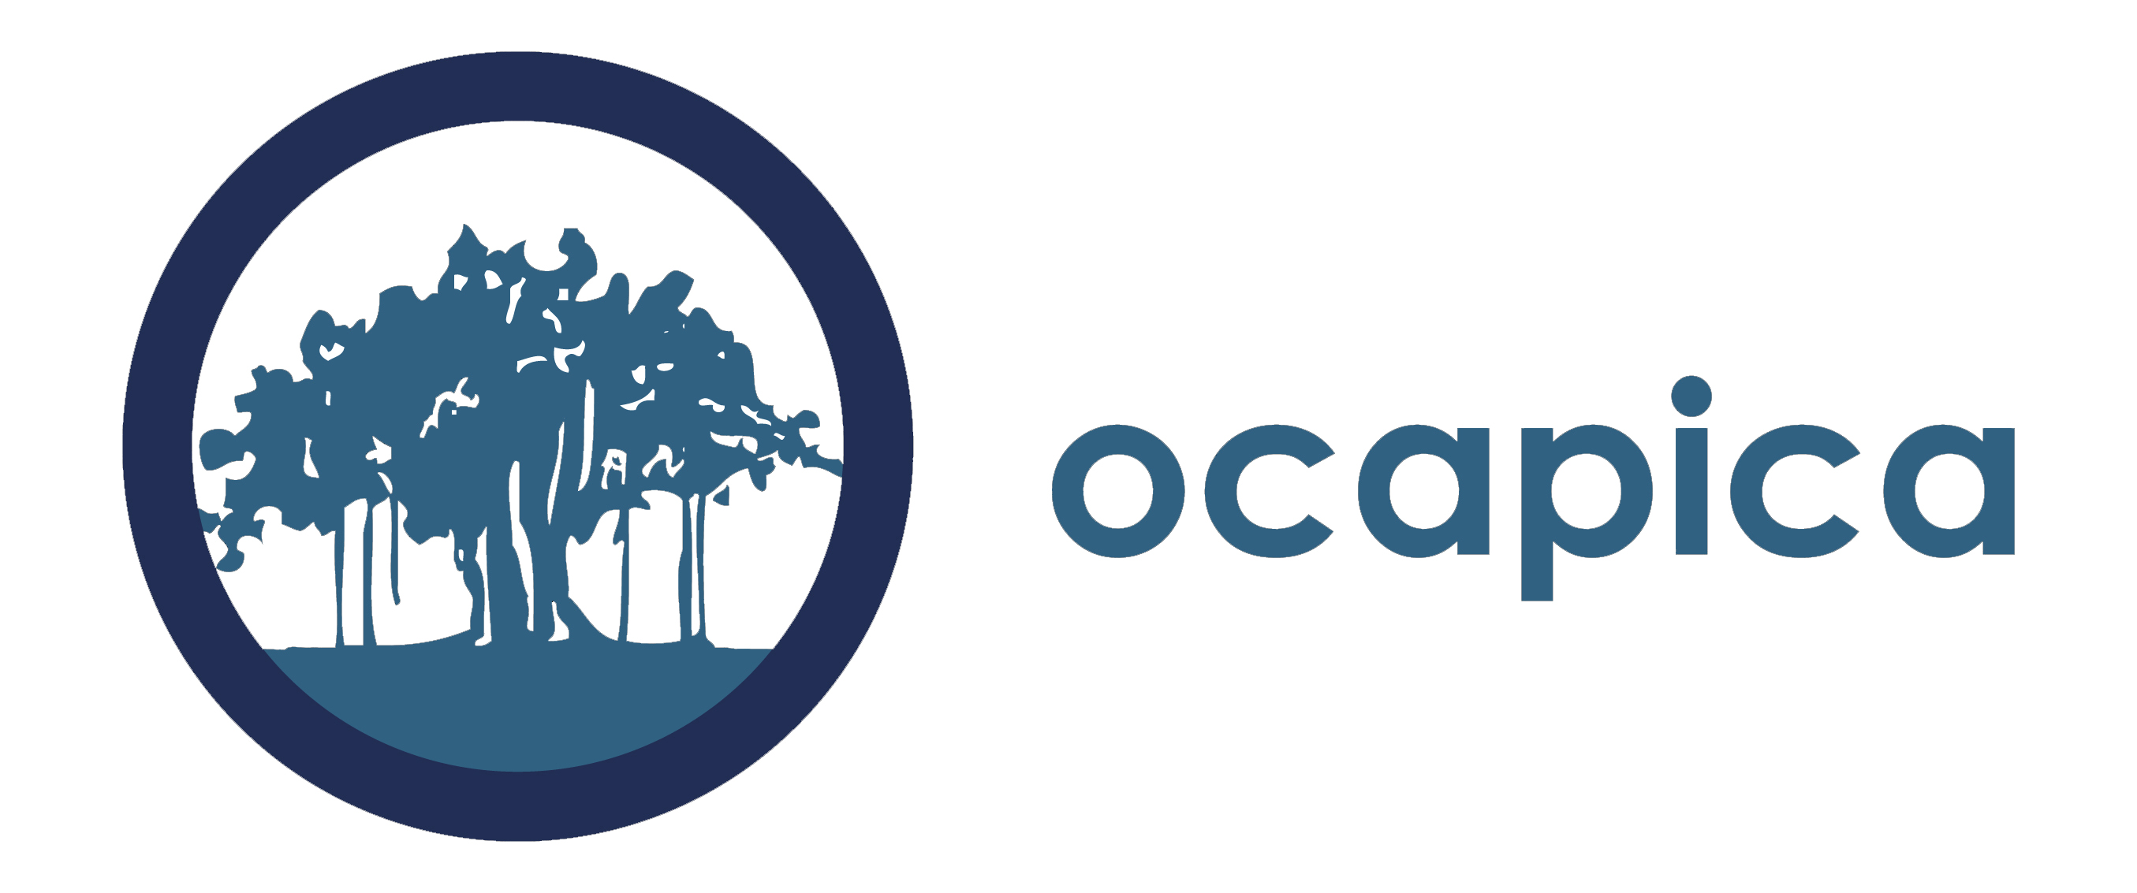

QuickStart Application Guidelines for
Community Co-PIs seeking a Scientist Co-PI

The Community co-PI should fill out the overview form on the next page (page 3) and provide a narrative overview in response to the questions on the following page (page 4). Combine all pages of the application into a single word document and email it to QuickStart@cabreastcancer.org by January 23, 2019, 5pm PST.

If the community co-PI is selected for the QuickStart program, the team will assist them in identifying and reaching out to potential scientist co-PIs to work with. Additionally, we will make introductions to scientists if we know of potential candidates. The QuickStart team cannot promise that the community co-PI will be able to find a partner in advance of starting the program, however all reasonable efforts will be made to facilitate a match.

Your complete application (excluding letters of reference and resumes) should not exceed six pages. A downloadable word version of this is also available on the QuickStart webpage: http://cbcrp.org/funding-opportunities/crc/quick-start-training.html

Please submit your application as a word document.

Application Checklist:
Please include the following in your completed application:

- Overview of Community Partner Seeking a Scientist Co-PI: See form on page 3.
- Application questions: See questions on page 4.
- Letter of Reference. Includes a letter of reference from the organization you represent demonstrating support for your participation in QuickStart.
- Resume (Not to exceed 4 pages).

Overview of Community Partner Seeking a Scientist Co-PI

Community Co-PI Name
Organization Name
Address
Email
Work Phone
Cell Phone
Fax Number
Executive Director Name
Work Phone
Email
Would you like the QuickStart team to help you find a scientific partner for the program? If not, please explain how you plan to find a partner for QuickStart.

Please describe the community you are a part of and/or represent.

What are the primary issues related to breast cancer or tobacco related disease that affect your community?

What disparities issues are of most concern to your community?

What environmental issues related to breast cancer or tobacco related disease are of most concern to your community?

Have you or your organization worked on a research project before? If so, please briefly describe.

Application Questions for a Community Co-PI Seeking a Scientific Co-PI

Prepare a two to three page overview in response to the questions below. Please include the questions with the answers filled in underneath when you submit.

- Describe the mission of your organization, the issues the organization focuses on, the geographic reach of the organization, the demographics of the population the organization serves, and the types of services the organization provides.
- Describe your role in your organization. What experience, interest and skills do you have that are relevant to conducting community-partnered participatory research?

- Describe your experience working in partnerships and/or collaborations generally and (if applicable) in community-partnered participatory research.
- Describe your organization’s experience collaborating with others beyond what you describe in #3.

- Describe your research interests. For example, describe the types of research questions that are interesting to you and the group/organization you are representing. Please be as detailed as possible. This is important if you would like assistance finding a scientist partner. The more we know about your interests, the better we will be able to help you.

- If there are other individuals who are likely to be significantly involved in the research process from your community group or organization, please describe them and their proposed contribution. Please note: if you would like one of them to be considered for participation in the program, please indicate who they are and why it would be important for them to participate. QuickStart cannot guarantee that more than the community co-PI and scientific co-PI will be able to participate in the program; however, we will consider a third partner if there is available space.

- Given the research needs and interests of the organization, why is the individual applying a good Community Co-PI candidate for this program?

- How will the organization select a replacement for you if you resign from your position?

- Is there anything else you would like the QuickStart team to know as we consider your application?

